|  |
| --- |
| Circle Language Spec: Commands |

## Target Command Definition

A target command definition is completely analogus to a *target class*.

A target command definition is found by following the redirections, that lead to a symbol’s command definition.

When you want to find the definition of a command, and the command is actually a command reference, you first need to follow all object reference redirections, to find the target command object. When you found the target command object, you can find the target command definition, by following one class redirection. Do not follow more than one class redirection, because if a definition points out a definition again, then the second definition is *another* command object, that the first definition is just *based* on. If the definition is a command reference itself, you have to follow all object redirections to find the target *definition* object. Then you have found the target command definition. That’s where redirection following ends. If the definition object has a definition itself, you might be tempted to follow the definition object’s class redirections as well, to find the final target definition, but you should not do that. If a definition object has a definition itself, then the definition object is only based on another definition, but it *is* an object of its own. An object redirection is just a much tighter bond like that, than a class redirection.

## Ideas

### Out of the original Symbol documentation

#### Definition Trace

The definition trace is quite easy: follow reference lines until you bump into a symbol without a reference line. That symbol’s the definition

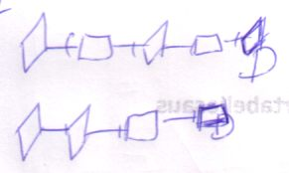

#### Execution-Definition Trace

Just as with the object-type trace, the execution trace requires you to find the definition anyway, so when you need both, the execution trace will suffice. It’s called a *execution-definition trace* when you use an execution trace to find both execution and definition.